**Chapter 1**

**Introduction**

**1.1 Overview**

The proposed Blood Bank management system helps the people who are in need of a blood by giving them all details of blood group availability or regarding the donors with the same blood group. The people in need of blood can search for the donors by giving their blood group and city name. It saves time as he can search donors online without going anywhere. Using this system user can get blood in time and can save his relative or friend life. Our website work 24x7 so user can get information of blood donor any time. Blood donor can also get registered and save life of other person. The main benefit of this system is the information of available blood group.

When blood is need in the operation then people have very less time to get the blood available so if he get the information like who can give him blood in time in his city is lifesaving. And here our system work, whenever a person need blood he get information of the person who has the same blood group he needs.

**1.2 Brief Description**

The Blood Donation Agent is to create an e-Information about the donor and organization that are related to donating the blood. Through this application any person who is interested in donating the blood can register himself in the same way if any organization wants to register itself with this site that can also register. More over if any general consumer wants to make request blood online he can also take the help of this site. Admin is the main authority who can do addition, deletion, and modification if required. The project has been planned to be having the view of distributed architecture, with centralized storage of the database. The application for the storage of the data has been planned. Using the constructs of MS-SQL Server and all the user interfaces have been designed using the PHP technologies.

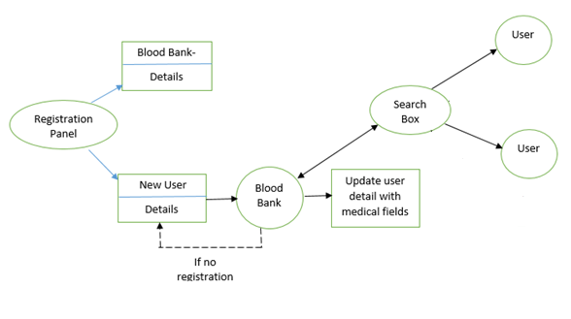

Fig.1.2.1: System Architecture